**Introduction to Pattern Recognition CSE 4/555**

**Assignment 2**

**Submitted By: Abhinav Kumar**

**Ub Person #: 50247660**

In this problem set, we will make exact inferences about probabilistic graphical models using the state-of-the-art graphical model packages in our most comfortable programming languages, and understand those exact algorithms. You can find tutorials in [Python](https://ublearns.buffalo.edu/bbcswebdav/pid-4499403-dt-content-rid-18203418_1/xid-18203418_1), R ([slides](http://people.math.aau.dk/~sorenh/misc/2014-useR-GMBN/bayesnet-slides.pdf) and [book](https://catalog.lib.buffalo.edu/vufind/Record/003839770)) and [Matlab](https://github.com/bayesnet/bnt" \t "_blank). The function calls in different packages are different, but the point here is that we make graphical model our actionable machine learning tool in this course.

We will work with the chest clinic graphical model (below). Please moralize, triangulate and construct a junction tree from this graphical model. Then use message-passing algorithm to find the joint probability of "tub=yes, lung=yes, bronc=yes", given evidence that "asia=yes, xray=yes".

**Problem 1: Draw the moral graph, triangulated graph and the junction tree. Explain why the "running intersection property" is satisfied in your junction tree.**

**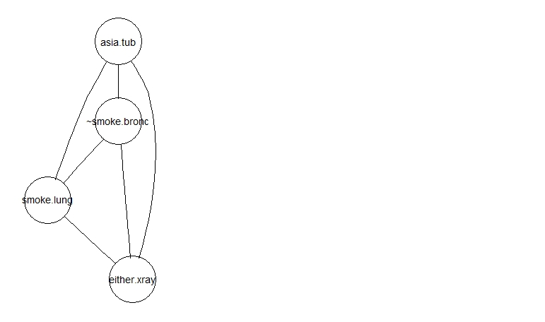**

**The running “Intersection property” is satisfied in the following way:**

The junction tree satisfies the non-intersection property because we find the find the orderings xc(1),.....xc(n) for all cliques c with the property that if xi<-xc(j) and xi<-xc(k) for some variable xi,then xi<-xc(l) for all xc(l) on the path between xc(i) and xc(j).

In our junction tree, for example bronc has the same marginal probability for all the cliques c.

**Problem 2: Describe how the different terms on the right hand side of "p(V ) = p(a)p(t | a)p(s)p(l | s)p(b | s)p(e | t, l)p(d | e, b)p(x | e)" are distributed among the different juction tree clusters. Write out the messages using these terms and verify that the message passing algorithm indeed gives the cluster marginal**

Distribution of different terms on the right hand side of "p(V ) = p(a)p(t | a)p(s)

p(l | s)p(b | s)p(e | t, l)p(d | e, b)p(x | e)" :

|  |  |  |
| --- | --- | --- |
| Source Clique | Sepsets | Destination Clique |
|  |  |  |
| asia tub | tub | either lung tub |
| either lung tub | either lung | either lung smoke |
| either lung smoke | either smoke | bronc either smoke |
| bronc either smoke | either | either xray |

The messages passed using these terms are the sepsets formed between the cliques:

1. Tub
2. Either lung
3. Either smoke
4. Either

The marginal probabilities are satisfied as we get the following probabilities for bronc,tub and lung :

Clique 1:

Bronc : 0.133659

Tub : 2.171959

Lung: 0.71564

Clique 2:

Bronc: 0.133659

Tub: 2.171959

Lung: 0.71564

Clique 3

Bronc : 0.133659

Tub : 2.171959

Lung : 0.71564

Clique 4

Bronc : 0.133659

Tub : 2.171959

Lung : 0.71564